

**CS205-OPERATING SYSTEMS**

**PROJECT REPORT**

Project Title:

**Comparison Between Multithreading And Multiprocessing**

Instructors:

Miss Nausheen Shoaib and Miss Sumaiyah Zahid

Section: D

Group Members:

Obaid Ur Rehman 17k-3848

Hina Waheed 17k-3862

Moosa Hussain 17k-3934

OBJECTIVE:

Our project will mainly focus on the differences between multithreading and multiprocessing. The performance comparison will be observed by the implementation of FOUR different series algorithms :

1. Fibonacci Series
2. Trag Series
3. Lazy Caterer Series
4. Catalan Series

INTRODUCTION:

Comparison will be shown on the basis of speed and input (number of elements in the series). All the above mentioned algorithms have been implemented using multithreading and multiprocessing along with the use of pipes.

PROGRAMMING PLATFORM USED:

⦁ The programming platform used is C Language

⦁ The operating system that we worked on is Ubuntu.

OBSERVATIONS

1. Fibonacci Series

|  |  |  |
| --- | --- | --- |
| Number of elements in series | Time (in milliseconds) taken by | |
| Process | Threads |
| 5 | 0.236 | 0.564 |
| 10 | 0.239 | 0.732 |
| 15 | 0.246 | 0.737 |
| 20 | 0.252 | 0.745 |
| 30 | 0.264 | 0.757 |
| 40 | 0.269 | 0.79 |
| 50 | 0.280 | 0.911 |
|  |  |  |

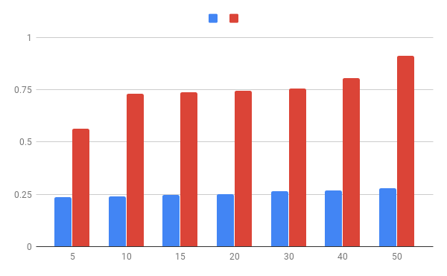

1. Trag Series

|  |  |  |
| --- | --- | --- |
| Number of elements in series | Time (in milliseconds) taken by | |
| Process | Threads |
| 5 | 0.244 | 0.635 |
| 10 | 0.259 | 0.692 |
| 15 | 0.288 | 0.715 |
| 20 | 0.300 | 0.727 |
| 30 | 0.315 | 0.759 |
| 40 | 0.342 | 0.782 |
| 50 | 0.354 | 0.837 |
|  |  |  |

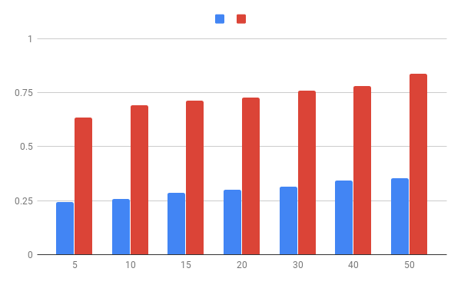

1. Lazy Caterer Series

|  |  |  |
| --- | --- | --- |
| Number of elements in series | Time (in milliseconds) taken by | |
| Process | Threads |
| 5 | 0.247 | 0.664 |
| 10 | 0.250 | 0.677 |
| 15 | 0.255 | 0.695 |
| 20 | 0.268 | 0.726 |
| 30 | 0.289 | 0.742 |
| 40 | 0.303 | 0.799 |
| 50 | 0.321 | 0.834 |

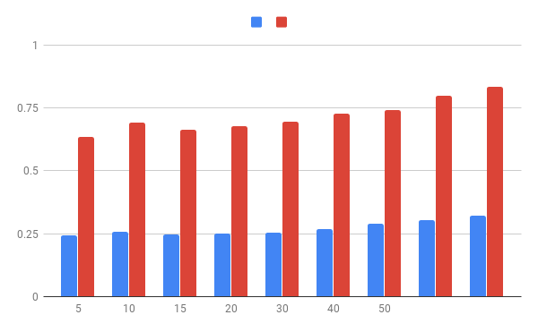

1. Catalan Series

|  |  |  |
| --- | --- | --- |
| Number of elements in series | Time (in milliseconds) taken by | |
| Process | Threads |
| 5 | 0.227 | 0.563 |
| 10 | 0.239 | 0.647 |
| 15 | 0.270 | 0.749 |
| 20 | 0.283 | 0.809 |
| 30 | 0.312 | 0.847 |

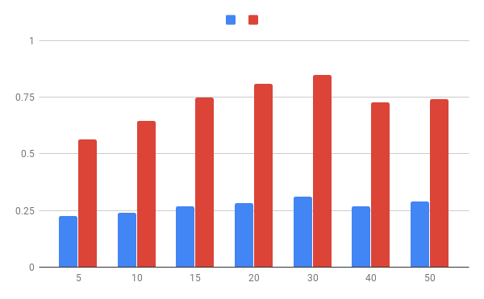

CONCLUSION:

From the above observations it can be drawn that multiprocessing is actually faster than multithreading because of the overhead of synchronization of threads in multithreading.